

SOLAR ADOPTION RATE across AUSTRALIA –

AN ANALYSIS

PREPARED BY
QUAN MAI – ID: 201 367 69

LEAD ANALYST
Yuthika Punchihewa

2026

EXECUTIVE SUMMARY

This analysis investigates the hypothesis regarding Australian solar adoption, specifically testing whether housing tenure (homeownership versus renting) acts as the primary barrier or driver for residential solar installations and consumptions.
By including decade-spanning data from the ABS Census (2011, 2016, 2021), this report evaluated state-by-state installation volumes and solar system capacities.
The results mathematically invalidate the hypothesis that housing tenure is the primary market driver.
Despite homeownership rates remained static across the decade, solar capacity per dwelling experienced exponential growth. Furthermore, the market underwent a structural shift where the volume of new installations decreased after 2011, but the physical capacity of installed systems increased.
Consequently, strategies and policies based on property ownership is not recommended for future ARENA initiatives, instead, structural, technological, or environmental factors must be prioritised.

INTRODUCTION
- Objectives: The primary goal is to test the hypothesis that state-level solar adoption is influenced by housing tenure. Specifically, renters are less likely to install solar energy systems, resulting in lower overall household solar energy consumption compared with owned households, whether the property is owned outright or financed through a mortgage. The analysis aims to determine whether states with higher homeownership rates tend to exhibit higher rates of solar adoption.
- Approach: The study tracks three distinct ABS Census periods (2011, 2016, 2021) against corresponding solar installation and capacity data. By standardizing raw solar output and installation volumes against dwelling counts and mapping it against housing tenure profiles, the analysis evaluates trends independent of human population sizes.
- Scope and restrictions: The analysis is restricted to aggregated state level data. It does not account for other variables such as local council rebates, household income, or specific property types (apartments or detached housing) which may also influence adoption rates.

METHODOLOGY
- Data Sources:
Population_by_State 2011_2025
australian_postcodes
sgu-solar-capacity-2011-to-present-and-totals
sgu-solar-installations-2011-to-present-and-totals
External datasets:
ABS Census 2011, 2016 and 2021
https://www.abs.gov.au/census/find-census-data/datapacks

- Analytical tools: Pandas for data analysis and Seaborn for visualizations
- Security Measures: Since the ABS Census datasets are publicly available, no sensitive information was handled during this project. However, to ensure data integrity and security, all raw CSV files were treated as read-only. Data cleaning and transformations were executed entirely within the kernel's memory, ensuring the original source files could not be accidentally overwritten.
- Validation Checks: Pandas functions such as info(), head(), shape() ensured all rows and columns were imported properly, and numeric fields were not treated as text strings. Missing value audits using isnull() and sum() verified data completeness.
- Data Preparation:
- Alignment: Solar installation and capacity data were grouped and summed annually to align with the 2011, 2016, and 2021 ABS Census years.
- Standardisation: To ensure a fair comparison, raw solar capacity and installations was standardised.
A test was conducted to compare standardisation by human population versus physical dwellings.
It was found that standardising by human population introduces a "family size penalty," which depresses the adoption metrics of states with larger household sizes (such as the Northern Territory, Western Australia and Queensland) – see bar chart below.

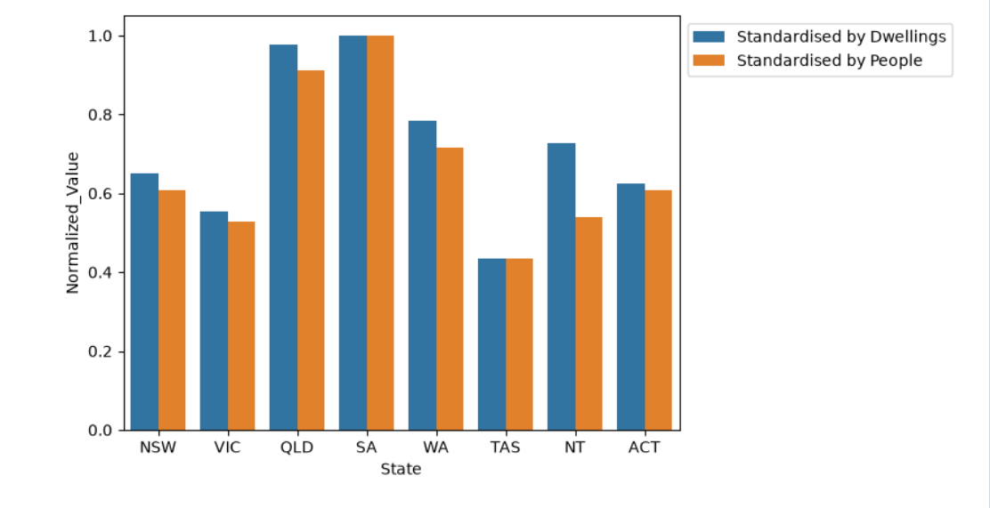
This chart shows the raw solar capacity (kW) in 2021 standardized against both total dwellings and human population, normalized to a 0 to 1 scale to ensure fairness in bar-to-bar comparisons.
Because solar systems are installed on physical roofs rather than individuals (human), when using human population and not dwellings (buildings) as a metric, it introduces a distortion in the results. States with larger family sizes suffer a depress in solar adoption metrics (lower red bars) compared to their actual rood infrastructure saturation (higher blue bars).
Consequently, the human population dataset was deliberately excluded from the results.
All solar metrics were standardised against total dwellings to reflect actual available roof infrastructure.

ANALYSIS AND FINDINGS
The integrated data reveals two critical insights that disprove the proposed hypothesis:
1. The Decoupling of Tenure and Adoption

This multi variable analysis (see bubble chart) shows ownership percentage against installations per dwelling and kW per dwelling reveals no meaningful correlation.
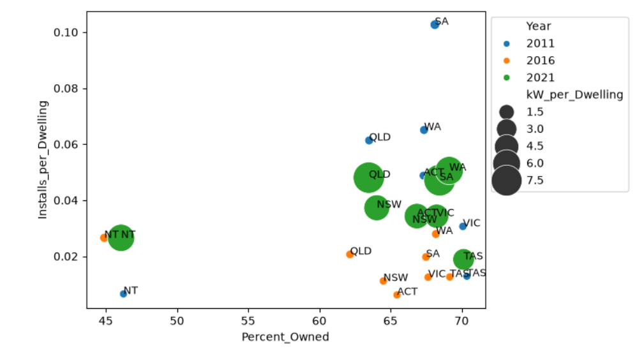
Between 2011 and 2021, homeownership rates remained nearly static across all states. However, over the exact same period, standard solar capacity (kW per dwelling) exploded. If the hypothesis was correct, the massive surge in solar capacity could not have occurred within a flat homeownership market.

2. The Shift from Volume to Capacity
Standardized analysis reveals a distinct market growth.
The volume of new installations per dwelling peaked during 2011 and declined or plateaued in markets like South Australia and Queensland.

However, the capacity of the systems being installed increased dramatically by 2021. This suggests that although fewer individual roofs were installed with solar panels in 2021 than in 2011, the panels installed were larger or more capable.

While the reasons for this increase are unclear, technological advancements, declining hardware costs, and other factors may have contributed to this trend.

This increase in solar capacity suggests that solar adoption rate may be independent from the renting-versus-owning hypothesis.

DISCUSSIONS
The findings suggest that although renting is a real challenge for tenants to adopt solar systems in their homes, they are not the main factor affecting the state-wide solar adoption rate. Between 2011 and 2021, the market shifted from many smaller installations to fewer but larger or more capable ones without any major changes in homeownership demographics.
For ARENA stakeholders, this indicates that demographic profiling for making future strategies or policies based on housing tenure is an inefficient method. The data suggests that other factors – including technical, environmental or social factors – are overriding the friction of housing tenure.

RECOMMENDATIONS
- Update Planning Metrics: ARENA should change its focus away from homeownership rates when making future solar adoption strategies and policies.
- Prioritize Capacity over Volume: The market is naturally moving toward larger solar systems. Future policies should focus on battery storage and grid integration for these larger systems, rather than just trying to increase the total number of new installations.
- Further Research: Future analysis should test environmental and social factors. Combining this dwelling data with weather data (such as sunlight hours from the Open-Meteo API) will likely explain the state-by-state differences much better than housing tenure data.

REFERENCES
Australian Bureau of Statistics (ABS). (2011, 2016, 2021). Census of Population and Housing.
https://www.abs.gov.au/census/find-census-data/datapacks

